**Electronic supplementary information**

**NOVEL µ-BRIDGED HETEROMETALLIC HETEROLEPTIC  
MACROCYCLIC TETRAPYRROLE COMPLEXES AS  
A MOLECULAR PLATFORM FOR CATALYSIS**

V. S. Sukharev,a,b S. A. Zdanovich,a E. Yu. Tyulyaeva,*a and S. V. Zaitsevaa

a Krestov Institute of Solution Chemistry, Russian Academy of Sciences,  
ul. Akademicheskaya 1, Ivanovo, 153045 Russia

b Ivanovo State University of Chemistry and Technology,  
Sheremet'evskii pr. 7, Ivanovo, 153000 Russia

**This PDF file includes**

Materials and methods, synthesis, structures and characterization of complexes, procedure of β- carotene oxidation, Supplementary Figures S1 – S9

# Materials and methods

All commercial reagents were of the best available purity and were used as supplied unless otherwise specified. *Tert*-butylhydroperoxide (tBuOOH) and dichloromethane were purchased from Aldrich Chemical Co. (CO)Ru(tBu)4Pc, ClFeTPP, ClMnTPP and (AcO)Mn(tBu)4Pc were obtained through PorphyChem and used as provided. Benzene was purchased from Aldrich Chemical Co. and was freshly distilled prior to use for experiment. N3MnTPP were prepared as elsewhere [1].

A Cary 50 UV-visible spectrophotometer and a EPR spectrometer Bruker EMXmicrom were used to record the UV-visible Т = 295К and EPR spectra at Т = 100К. FTIR spectra were acquired on a Bruker Vertex V80 using MVP 2 SeriesTM (Harrick) unit, in the frequency range 4000–400 cm–1 (64 scans on the average) with the resolution 2 cm–1 at the standard temperature. Chemical shifts (ppm) are reported relative to TMS. MALDI TOF spectrometry data was collected using a Mass Spectrometer Shimadzu Axima Confidence.

# Electrochemistry

Electrochemical measurements were performed by the cyclic voltammetry (CV) method with using a Potentiostat Biologic SP-150 according to procedure described elsewhere [2]. The CV response was recorded at scan rate 0.02 V/s. The CV data were corrected for Ohmic (iR) losses using the current interruption technique. The experiments were carried out in a three- electrode temperature-controlled (25 ± 0.5°C) electrochemical cell in freshly prepared solutions.

As working electrode, we used a polishing Au strip (Dropsens DRP-C220AT) rigidly fixed in the fluoroplastic lid. The active surface of the working electrode was carefully cleaned in distilled water before every measurement and then in the solution under study. Working electrode was immersed in the cell with the test solution where the potential of the working electrode reached a steady value in 10 min. Argon was bubbled through the capillary tube for 30 min in order to deoxygenate solutions before the electrochemical measurements. Deoxygenation process was performed to avoid a superoxo-anion-radical formation O2 + ē → O2•– [3, 4].

Dimethylformamide (DMF≥ 98.0, ALDRICH) was used without purification. Tetrabutylammonium perchlorate (TBAP ≥ 98.0, ALDRICH) was purified by recrystallization from ethanol. Solution of dimer (*C* = 10–4 M) contains 0.02 M TBAP as the supporting electrolyte.

# Oxidative decomposition of β-carotene

Oxidation of β-carotene was conducted by allowing the compounds **1** – **3** to react with peroxide (*СtBuOOH* = 0.27 mM) that resulted in single- or doubly-oxidized species of **1** – **3** (according to the UV-visible spectra), and then adding substrate. All the reactions were performed at room temperature in 3 mL cuvette. The dye decay was controlled spectrophotometrically by decrease in intensity of the absorption band of carotene at 464 nm. When the latter disappeared β-carotene aliquot was put into the system to recycle the reaction without any oxidant adding.

# Synthesis and characterization of complexes 1, 2 and 3

**Compounds 1** and **2** were prepared according to the modified literature report [5].

**µ-Carbido-[(tetra-tBu-phthalocyaninato)ruthenium(IV)-(tetraphenylporphyrinato)- manganese(IV)], (tBu)4PcRu=C=MnTPP** (**1**). ClMnTPP and (CO)RuPc(tBu)4 in molar ratio 1:1 were dissolved in 2-propanol (20 ml) with potassium hydroxide (1 g, 0.018 mol) and refluxed at 85oC, with vigorous evaporation of the alcohol, until the color of the solution changed (20 min). CHCl3 (3 ml) was added cautiously to the boiling solution, and, after the vigorous reaction had stopped, the precipitation of the μ-carbido complex was completed by addition of water (50 ml). The crude product, consisting of three species, was then purified with column chromatography on silica gel using 10:1 and 9:1 petroleum ether/dioxane as mobile phase. The organic layer, containing mainly heterobimetal μ-carbido complexes, was selected and purified on chromatography column with silica gel firstly with CH2Cl2 to select by-products. CH2Cl2–THF (1:1) was then used to elute the desired product which was then evaporated to dryness, affording complex (tBu)4PcRu=C=MnTPP as dark blue solid (25 %).

UV-visible in CH2Cl2 λmax, nm (log ε): 648 (4.67), 589 (4.2), 514 (3.84), 418 (4.98), 319 (4.88);

IR (KBr) ν, cm–1: 983 (νas Ru=C=Mn);

MALDI-TOF: *m/z* found 1517.77 [M]+, calculated for [C93H76N12MnRu]+ – 1517.47;

half-wave potentials (CH2Cl2/0.02 M TBAP): $E_{1}^{1/2}=+0.29 V$, $E_{2}^{1/2}=+0.41 V$, $E_{3}^{1/2}=+0.98 V$.

**µ-Carbido-[(tetra-tBu-phthalocyaninato)manganese(IV)-(tetraphenyl- porphyrinato)iron(IV)], (tBu)4PcMn=C=FeTPP (2)** was obtained according to a procedure similar to that described for **1**, using ClMnPc(tBu)4 and ClFeTPP as precursors. Column chromatography afforded the violet solid product (25 %).

UV-visible in CH2Cl2 λmax, nm (log ε): 710 (4.41), 611 (3.56), 570 (3.82), 414 (4.92), 312 (4.33);

IR (KBr) ν, cm–1: 988 (νas Mn=C=Fe);

MALDI-TOF: *m/z* found 1472.34 [M]+, calculated for [C93H76N12FeMn]+ – 1472.51;

half-wave potentials (CH2Cl2/0.02 M TBAP): $E_{1}^{1/2}=+0.37 V$, $E_{2}^{1/2}=+0.58 V$, $E_{3}^{1/2}=+1.17 V$.

**µ**-**Nitrido-[(tetra-tBu-phthalocyaninato)manganese(III)- (tetraphenylporphyrinato)iron(IV)], (tBu)4PcMn–N=FeTPP (3)** was produced following previously reported work [6] by interaction of N3MnPc(tBu)4 with (Cl)FeTPP (molar ratio 1.4:1) in xylene (5 mL). Column chromatography (silica, CH2Cl2/hexane = 1:1) afforded the vermillion red product (23.4%).

UV-visible in CH2Cl2 λmax, nm (log ε): 688 (4.95), 621 (4.28), 511 (3.67), 415 (4.56), 338 (4.74);

IR (KBr) ν, cm–1: 954 (νas Mn–N=Fe);

MALDI-TOF: *m/z* found 1474.59 [M]+, calculated for [C92H76N13FeMn]+ – 1474.61;

half-wave potentials (CH2Cl2/0.02 M TBAP): , , .

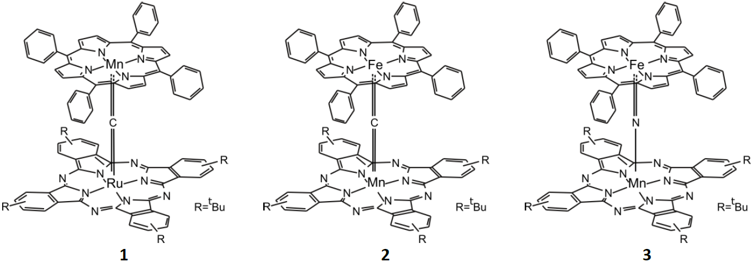

**Structure** of dimers:  
(tBu)4PcRu=C=MnTPP, **1** (M1=Mn, M2=Ru, X=C);  
(tBu)4PcMn=C=FeTPP, **2** (M1=Fe, M2=Mn, X=C);  
(tBu)4PcMn–N=FeTPP, **3** (M1=Fe, M2=Mn, X=N)

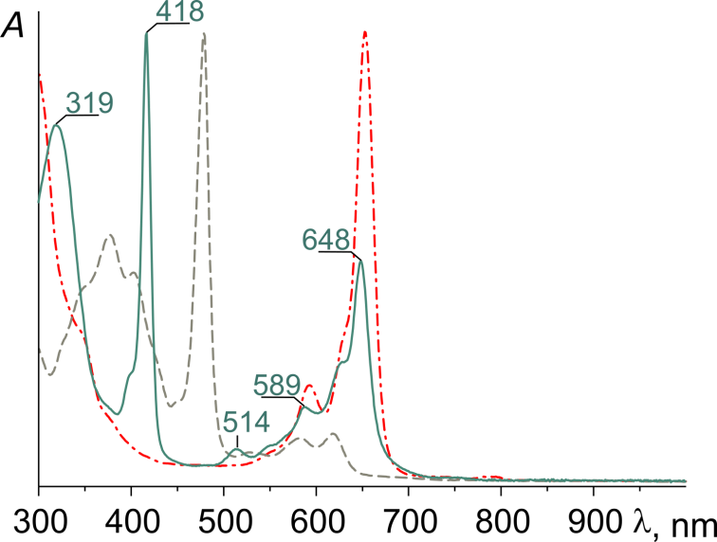

**Figure S1.** UV-visible spectra in CH2Cl2:  
**1** (green line); ClMnTPP (grey line); (CO)Ru(tBu)4Pc (red line)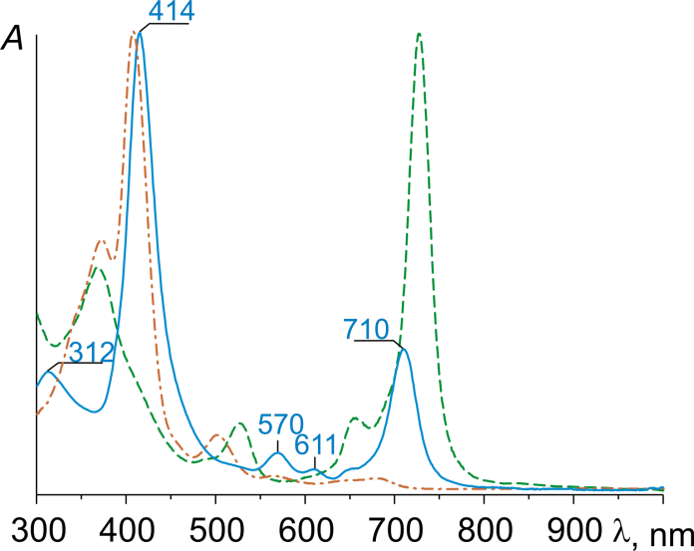

**Figure S2.** UV-visible spectra in CH2Cl2:  
**2** (blue line); ClFeTPP (orange line); ClMn(tBu)4Pc (green line)

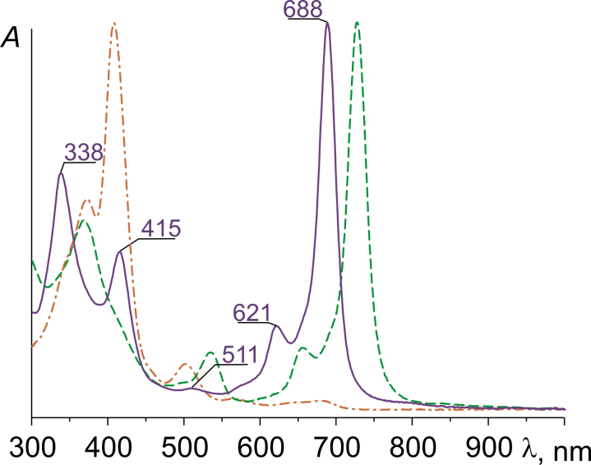**Figure S3.** UV-visible spectra in CH2Cl2:  
**3** (violet line); ClFeTPP (orange line); (AcO)Mn(tBu)4Pc (green line)

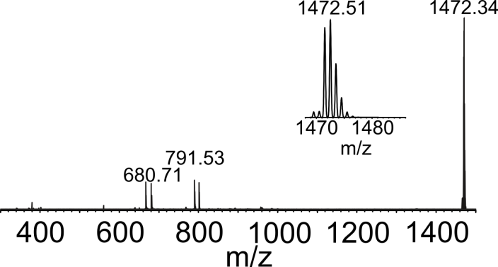

**Figure S4.** MALDI TOF spectrum of (tBu)4PcMn=C=FeTPP (**2**) in CH2Cl2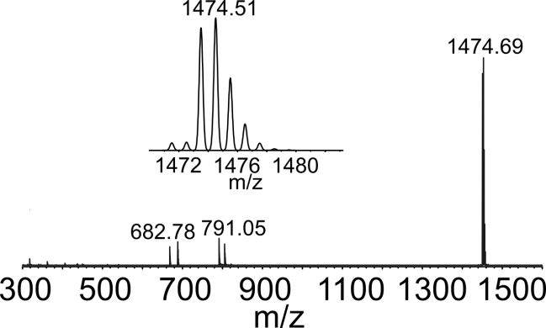

**Figure S5.** MALDI TOF spectrum of (tBu)4PcMn–N=FeTPP (**3**) in CH2Cl2

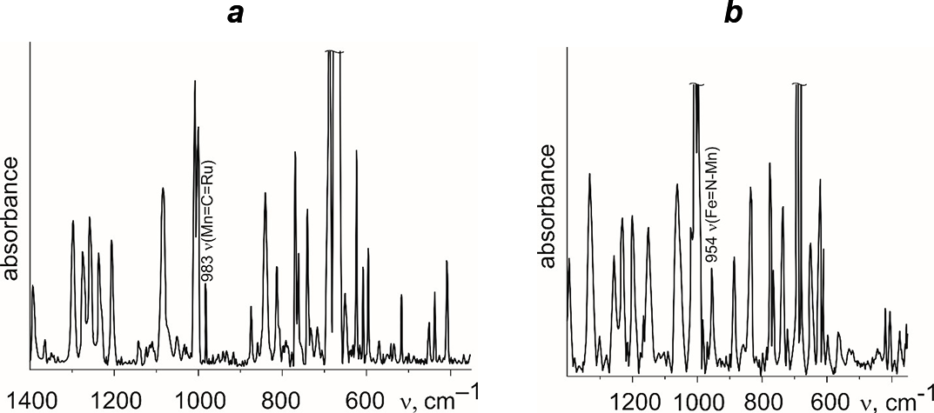

**Figure S6.** IR spectra (KBr) of **1** (a) and **3** (b)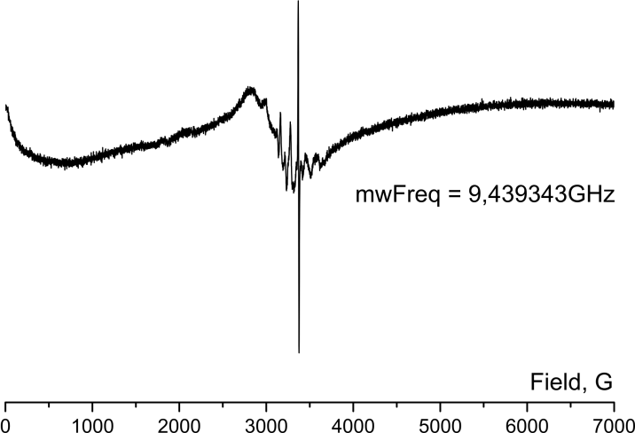

**Figure S7.** EPR spectra of **3** in THF at 100 K

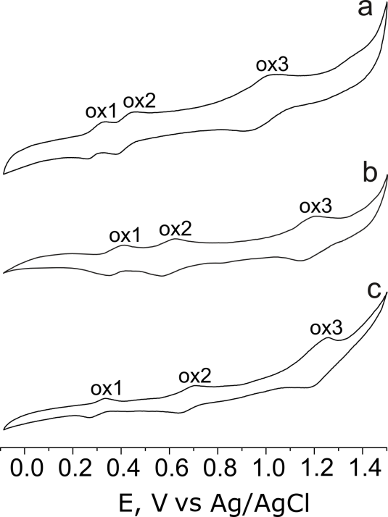

**Figure S8.** Cyclic voltammograms of compounds in CH2Cl2  
with 0.02 M TBAP electrolyte: **1** (a), **2** (b) **3** (c)

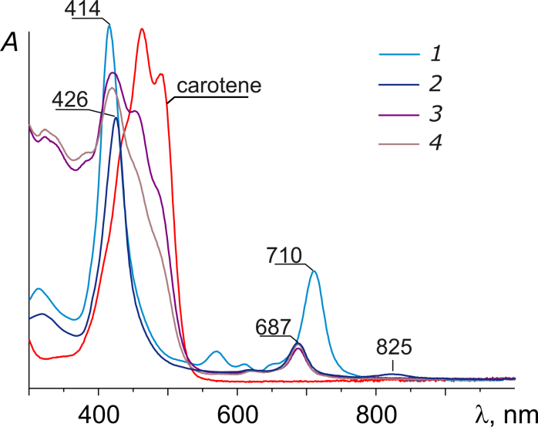

**Figure S9**. Spectra in CH2Cl2 at 23 ℃: **2** (*C*1 = 1.95∙10–6 M) (*1*);  
**2**–tBuOOH system in 5 min after mixing (*2*); **2**–tBuOOH–β-carotene system  
(*C*Car = 0.33 mM)when mixed (*3*) and in 3 min after mixing

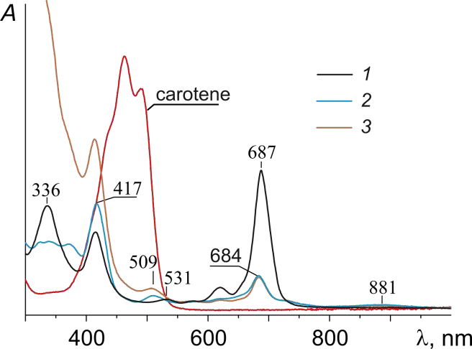

**Figure S10**. Spectra in CH2Cl2 at 23 ℃: **3** (*C*1 = 1.95∙10–6 M) (*1*);  
**3**–tBuOOH system in 5 min after mixing (*2*);  
**3**–tBuOOH–β-carotene system (*C*Car = 0.33 mM) when mixed (*3*)

**References**

1. H. Ogoshi, E. Watanbe, Z. Yoshida, J. Kincaid, K. Nakamoto, *J. Am. Chem. Soc.*,**1973**, *95*, 2845–2849. DOI: 10.1021/ja00790a017

2. S. M. Kuzmin, S. A. Chulovskaya, V. I. Parfenyuk, *J. Porphyrins Phthalocyanines*, **2014**, *18*, 585–593. DOI: 10.1142/S108842461450031X

3. S. M. Kuzmin, S. A. Chulovskaya, V. I. Parfenyuk, *J. Porphyrins Phthalocyanines*, **2015**, *19*, 1053–1062. DOI: 10.1142/S1088424615500807

4. S. A. Chulovskaya, S. M. Kuzmin, V. I. Parfenyuk, *Mendeleev Commun*., **2017**, *27*, 470–472. DOI: 10.1016/j.mencom.2017.09.013

5. A. Kienast, L. Galich, K. S. Murray, B. Moubaraki, G. Lazarev, J. D. Cashion, H. Homborg. *J. Porphyrins Phthalocyanines*, **1997**, *1*, 141–157. DOI: 10.1002/(SICI)1099-1409(199704)1:2<141::AID-JPP18>3.0.CO;2-M

6. D. A. Summerville, I. A. Cohen, *J. Am. Chem. Soc.*, **1976**, *98*, 1747–1752. DOI: 10.1021/ja00423a019